Title: Manual isolation of nuclei from human brain using CellRaft device and single nucleus Whole Genome Amplification
Authors: Ester Kalef-Ezra, Diego Perez-Rodriguez, Christos Proukakis
Affiliations: Department of Clinical and Movement Neurosciences, Queen Square Institute of Neurology, University College London, London, UK
Abstract: Protocol for manual nuclear isolation from human brain tissue using CellRaft device for single cell Whole Genome Amplification

Key words: single cell, Whole Genome Amplification, CellRaft, somatic mutation

Disclaimers:
This procedure was adapted from:
- Wierman MB, Burbulis IE, Chronister WD, Bekiranov S, MJ MC (2017) Single cell CNV detection in neuronal nuclei. In: Springer (ed) Genomic Mosaicism in Neurons and Cell Types (editors: Frade JM, Gage FH). New York, USA: Humana Press, Springer Nature; ISBN 978-1-4939-7279-1
- Perez-Rodriguez D, Kalyva M, Leija-Salazar M, et al. Investigation of somatic CNVs in brains of synucleinopathy cases using targeted SNCA analysis and single cell sequencing. Acta Neuropathol Commun. 2019;7(1):219. Published 2019 Dec 23
- Perez-Rodriguez D, Kalyva M, Santucci C, Proukakis C (2022) Somatic CNV Detection by Single-Cell Whole-Genome Sequencing in Postmortem Human Brain. In: Methods in Molecular Biology: Alzheimer’s disease. Vol. 2561, Jerold Chun (Ed)
Figure 1 was created with BioRender.com

Safety Warnings:
Please follow the Safety Data Sheets (SDS) for all reagents for safe handling and safety hazards

Commercial Reagents:
Item | Supplier | Catalogue Number | Preparation prior use | Storage
UltraPure DNase/RNase-Free Distilled Water | Thermo Fisher Scientific | 10977049 | Aliquot | RT
PBS (Phosphate Buffered Saline) 10X Solution (pH 7.4) | Fisher Scientific | 15815418 | Make 1x with dH₂O | Fridge
50x cOmplete Protease Inhibitor Cocktail EDTA-free | Roche via Sigma Aldrich | 4693159001 | Use 1 tablet in 1 ml dH₂O | Freezer (20ºC)
Triton-X100 | Sigma Aldrich | T9287 | Prepare 10% aliquot | RT
ODGM (Optiprep Density Gradient Medium) | Sigma Aldrich | D1556 | Aliquot | Fridge
Goat Serum | Sigma Aldrich | G9023 | Aliquot | Freezer (20ºC)
Cell-Tak™ Cell and Tissue Adhesive | Corning via Sigma Aldrich | DLW354242 | No | Fridge
DNase I Solution (1 unit/μL), RNase-free | Thermo Fisher Scientific | 89836 | Dilute to DNase solution, 200 U/mL and Aliquot | Freezer (20ºC)
TE Buffer (low EDTA) | Thermo Fisher Scientific | 12090-015 | Aliquot | RT

Home-Made Reagents:
Item | Sterilization Method | Storage
1 M MgCl₂ | Autoclave | RT
1 M Tris/HCl pH 8.8 | Autoclave | RT
1 M Sucrose: Filtered | Filtration | Freezer (-20ºC)
1 M KCl | Autoclave | RT
1 mg/ml DAPI (4′,6-diamidino-2-phenylindole) | No | Freezer (-20ºC)
10% Presept | No | RT
0.1 M NaOH solution | Filtration | Fridge
2.5 mM NaOH in PBS | Filtration | Fridge
70% EtOH in dH₂O | No | RT

Antibodies for immunodetection
Antibody | Supplier | Catalogue Number | Produced in | Working Concentration
Sox6 (dopaminergic neuronal nuclei) | Merck | HPA001923 | Rabbit | 0.5 μg/ml
Olig2 (oligodendrocyte nuclei) | Abcam | Ab109186 | Rabbit | 1 μg/ml
aSyn (alpha-synuclein) | Santa Cruz Biotechnology | sc-12767 | Mouse | 1 μg/ml
NeuN clone A60 (cortical neuronal nuclei)* | Millipore | MAB377 | Mouse | 10 μg/ml
Secondary anti-mouse IgG conjugated with Alexa (568) | Life Technologies | A21235 | goat | 2 μg/ml
Secondary anti-rabbit IgG conjugated with Alexa (488) | Life Technologies | A11008 | goat | 2 μg/ml
*Note: According to MAB377X description, this antibody works for most neuronal cell types throughout the adult nervous system. However, some neurons fail to be recognized by NeuN at all ages: INL retinal cells, Cajal-Retzius cells, Purkinje cells, inferior olivary and dentate nucleus neurons, and sympathetic ganglion cells and dopaminergic neurons (Mullen et al., 1992; Wolf et al., 1996., Cannon et al., 2009)

Specialized consumables:
- CytoSort 200, single, 5-pack - Cell Microsystems - 20200301CS

General consumables:
- Low binding filtered tips (sterile)
- Low-binding 1.5ml and 0.2 ml tubes (sterile)
- Screwed lid transparent 1.5-2 ml tubes (sterile)
- 1ml syringe without needle (sterile)
- PES Syringe filter, 0.2 µm (sterile)
- Gloves
- Strong glue e.g., super glue
- Adhesive tape

Equipment:
- Tissue culture hood for human sample handling
- PCR cabinet (Here, we used Air Science, Lydiate, UK)
- Dounce tissue grinder set 2 mL (Kimble via Sigma Aldrich - D8938)
- Refrigerated centrifuge for 1.5ml tubes that can achieve at least 13000 x g (here used Sigma Aldrich 1 - 14K Refrigerated Micro Centrifuge)
- Orbital Shaker (here used Grant instruments Orbital Shaker PSU-10i)
- Haemocytometer
- Inverted microscope (Here we used Nikon Eclipse TE300 inverted microscope coupled to a CCD camera - KERN optics)
- CellRaft accessory device (Cell Microsystems, Durham, US), with single reservoir CytoSort array (10,000 rafts)
- Stereoscope
- General lab pipettes
- Pair of forceps and scissors

Experiment

Critical note: Unless otherwise indicated, all the reagents must be kept at 4ºC and all the steps in the protocol must be performed at 4ºC. To preserve nuclear integrity, all the solutions are supplemented with complete cOmplete EDTA-free Protease Inhibitor Cocktail.

Section 1: Nuclear extraction from human brain
Before starting:
- Clean Human Tissue handling hood with 0.2 M NaOH, 10% Presept, 70% EtOH and dH₂O
- Clean Dounce tissue grinder (prior to use, between samples, and at the end of the experiment) with 0.2 M NaOH, 10% Presept, 70% EtOH and dH₂O, and let them dry
- UV sterilize and clean PCR hood, centrifuge, pipettes etc. with 10% Presept, 70% EtOH and dH₂O
- Precool centrifuge @4ºC
- On the day of the experiment prepare the following Buffers and keep on ice:
- NIM (Nuclear Isolation Media): 25 mM KCl, 5 mM MgCl₂, 10 mM Tris-HCl pH 8.8, 250 mM sucrose and 1 mM dithiothreitol (DTT), 1x cOmplete EDTA-free Protease Inhibitor Cocktail
- ODN (Optiprep Diluent for Nuclei): 150 mM KCl, 30 mM MgCl2, 60 mM Tris-HCl pH 8.8, 250 mM sucrose, 1x cOmplete EDTA-free Protease Inhibitor Cocktail
- 25% iodixanol solution (NIM:ODGN:ODN 6:5:1)
- 29% iodixanol solution (ODGN: ODN 29:31)
- NSB (Nuclei Storage Buffer) - if needed: 5 mM MgCl₂, 50 mM Tris-HCl (pH 8.8), 166 mM sucrose and 1 mM dithiothreitol (DTT), 1x cOmplete EDTA-free Protease Inhibitor Cocktail
Procedure:
- Transfer 20-50 mg frozen brain tissue to microcentrifuge tube containing 500 μl of NIM. Transfer the tissue in a tube with the lid on using a pair of forceps.
Optional step: Mincing the tissue in small fragments over a glass plate on ice using a scalpel could significantly decrease the time needed for homogenization and facilitate the trituration with the pipette tips.
- Gently triturate the tissue with a cut pipette tip (1ml tip). Repeat several times with pipette tips cut less (estimate 3-4 different cut sizes). Tissue will be perfectly dissociated when able to pass through an uncut pipette tip.
- Measure the total volume using 1 ml pipette.
- Add Triton X-100 solution to the sample to achieve final concentration 0.1% (stock solution 10%)
- Homogenize using 2 ml Dounce tissue grinders:
  - Grinder A (loose, large clearance pestles): 2-3 strokes
  - Grinder B (tight, small clearance pestles): 8-12 strokes
Note: The sample solution should appear homogeneous at this point, but the use of the Dounce grinder allows nuclei to remain intact.
- Transfer the homogenate to a fresh 1.5 mL microcentrifuge tube
- Centrifuge at 1000g, 8 min, @4°C - Discard Supernatant
- Resuspend gently the pellet in 700 μl 25% Iodixanol Solution
- Layer the sample (avoiding mixing the phases) onto 700 μl 29% iodixanol solution. Use 1 mL syringe without needle to slowly load and suspend the sample on top. As a result, 2 clearly defined phases should appear as follows:
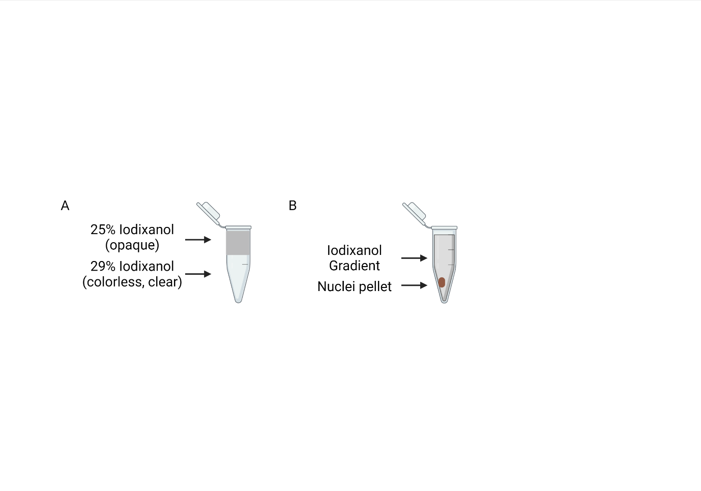
Figure 1. Nuclear isolation using iodixanol gradient. A. Gradient generation solution is generated from 25% iodixanol gradient containing the cell lysate on the top and 29% iodixanol gradient solution on the bottom. B. After centrifugation, the nuclear fraction is near the bottom of the tube.
- Spin at 10300 x g, 20 min, @4°C - Remove the supernatant leaving 50 µL in the bottom of the ultracentrifuge tube (contain the nuclear fraction).
- At this point, follow any of the below routes:
A. Store nuclear suspensions @4ºC
Note: Although we routinely use the nuclear suspensions on the day of preparation, others have reported those to be stable at @4°C for several weeks when stored in Nuclei Storage Buffer (Reed et al., 2017).
B. Proceed to DAPI staining
- Resuspend nuclei in DAPI (final 1 ug/ml) diluted in 1000 μl ice-cold PBS
- Incubate for 20min @4C (or 1h @4C)
- Spin at 800g, for 10min, @4°C - Remove the supernatant
- Resuspend nuclear pellet in 500 μl ice-cold PBS
- Check nuclei under the microscope using a hemacytometer
C. Proceed to Immunodetection of inclusions and/or cell type marker staining
Before starting:
- Prepare PBS: PBS 1x. Keep on ice until use.
- Prepare PBS/PIC: PBS 1x supplemented with 1x cOmplete EDTA-free Protease Inhibitor Cocktail. Keep on ice until use.
- Prepare Blocking Buffer: PBS+PIC supplemented with 10% goat serum. Keep on ice until use.
Procedure:
- Immediately after isolation, resuspend the pelleted nuclei in 500 μL of pre-chilled Blocking Buffer
- Incubate at 4ºC for 30 min with gentle shaking on a rotator disk to block non-specific binding sites
- Add primary antibody at the optimal concentration directly to the blocking buffer containing the nuclear suspension and incubate at 4ºC for 1 h with gentle shaking.
Note: The optimal working concentration for each antibody needs to be determined in advance by titration assays.
- Pellet nuclei by centrifugation at 800xg at 4ºC for 10 min, remove supernatant taking care not to disturb the pellet, and gently resuspend it in pre-chilled PBS to wash off excess primary antibody
- Pellet again the nuclei as stated above, discard supernatant
- Add 2 μg/ml goat anti-mouse and/or anti-rabbit secondary antibody and 1 μg/ml DAPI diluted in Blocking Buffer
- Incubate for 1 h at 4ºC with gentle shaking on a rotator disk
- After incubation, wash the excess of PBS by pelleting again the nuclei and resuspending them in fresh PBS/PIC

Section 2. Estimate nuclei number under the microscope
Use a haemocytometer to estimate the number of nuclei in the final suspension. In a good nuclear fraction, most of the nuclei should be seen as single, with few clumps and/or low amount of cellular/tissue debris.

Section 3. Manual isolation of single nuclei using a device fixed to an inverted microscope
Critical note: If possible, do sub-sections 1 and 2 in a PCR cabinet to minimize contamination.

Sub-section 1. CytoSort Array Preparation
- Visually inspect the CytoSort array prior opening. The pre-sterilized arrays are expected to have a red sticker on packaging. Remove the array from the sealed pouch.

Optional step: It may be possible to observe crystallization of excess glucose that was used to seal the CytoSort array from exposed air (Figure 2B). In that case:
- Wash the array with 2 ml (pre-warmed @37ºC) PBS 1x – incubate for 3 min
- Repeat above step 3 times in total
- Cool the array @RT
- Continue to the next steps

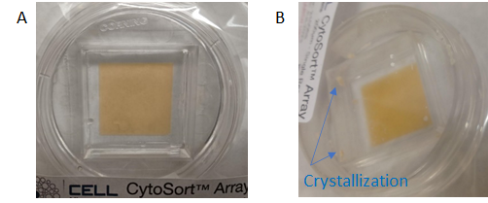
Figure 2. Examples of CytoSort arrays prior to opening (A) without, and (B) with crystallization.

- Wash with 2 ml dH₂O – incubate for 3 min @RT – Remove water
- Repeat the washing with 2 ml dH₂O – incubate for 3 min @RT - Remove water
- Apply 1 ml of 15 ug/mL Cell-Tak in PBS with 2.5 mM NaOH – incubate for 20 min @RT – Remove Cell-Talk
- Add 2 ml sterile PBS 1x - Incubate for 3 min @RT – Remove PBS
- Repeat step 5 (3 times in total)

Sub-section 2. Seeding nuclei to the CytoSort array
Optional step: Insert the CellRaft seeding insert to increase the overall number of single cells available for isolation.

- Dilute approximately 5000 nuclei in 2 mL of PBS, add pipette them dropwise in the centre of the CytoSort Array
Critical note: Nuclei should be counted in a haemocytometer prior to seeding. The number of nuclei seeded on the array is a key factor, as too many will lead to few CellRafts with single nuclei, while too little will lead to most of the CellRafts being empty, according to a Poisson distribution. Thus, seeding the array with a nuclei: wells ratio 1:2 or 1:3 increases the proportion of wells capturing a single nucleus versus wells capturing none or >2 nuclei.

2. Move carefully the CytoSort Array to ensure the nuclei settle evenly within the array (like seeding cells for cell culture)
- Allow it to settle for 2h – O/N in the fridge.
Note 1: Use parafilm, paper towel and foil to properly seal the array to prevent desiccation
Note 2: From our experience, nuclei are stable on the array for up to 2 weeks when stored properly sealed in the fridge.

Section 3. View CytoSort Arays under the microscope, capture & transfer rafts with single nuclei in tubes for single cell Whole Genome Amplification
Before starting:
- Defreeze an aliquot of diluted DNase I Solution and keep @RT
- Prepare aliquots of 50 µl of 70% EtOH and 50 µl of dH₂O in 1.5ml tubes in a PCR hood and keep @RT until use. You will need at least 1 aliquot of 70% EtOH and dH₂O for each sample you want to amplify. As an example, if you aim to amplify the genome of 10 single nuclei, prepare 15 aliquots of 50 µl of 70% EtOH and 50 µl of dH₂O.
- Prepare 0.2ml tubes with buffer depending on the downstream single cell Whole Genome Amplification (scWGA) method: (estimate double the number of tubes than the single nuclei to be collected)
  - Multiple displacement amplification (MDA) in droplets (dMDA, Samplix): 2.8µl Lysis Bf (200 mM KOH, 5 mM EDTA pH 8 and 40 mM 1.4 DTT) diluted in 2 µl dH₂O
  - PicoPlex (Takara): 5µl TE/Cell Extraction Buffer (depending on the version of the PicoPlex protocol used)
  - Primary Template-directed Amplification/Resolve DNA (PTA, BioSkryB): 3µl Cell Buffer (BioSkryB)
- Mount the CellRaft® Release Device is mounted onto a 4× or 10× objective of an inverted microscope and prepare the CytoSort Array for observation under the microscope. For details on this process please see the attached protocols (Attach CytoSort Array and CellRaft protocols):
- Cell Microsystems: CellRaft System for Inverted Microscopes (user manual)
- Cell Microsystems: CytoSort Array (user manual)
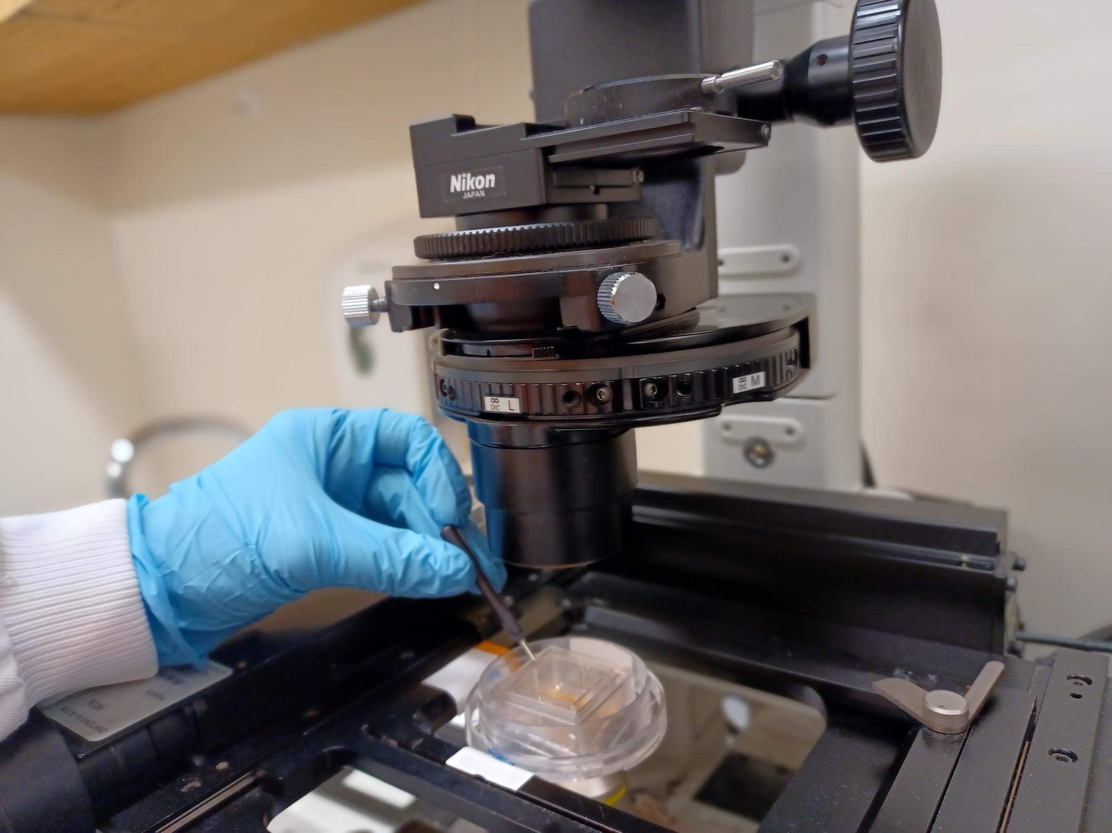
Figure 3. A CytoSort Array is attached to the microscope to allow observation of the rafts and manual picking using a magnetic wand.

B. Isolation of rafts containing the nuclei of interest
- View CytoSort Arrays under the 10x magnification objective with appropriate fluorescence filters, to select rafts (microwells) containing a single nucleus with the desired characteristics and take photos (if needed) (Fig 4A)
- Individually release the arrays of interest (Figure 4B)

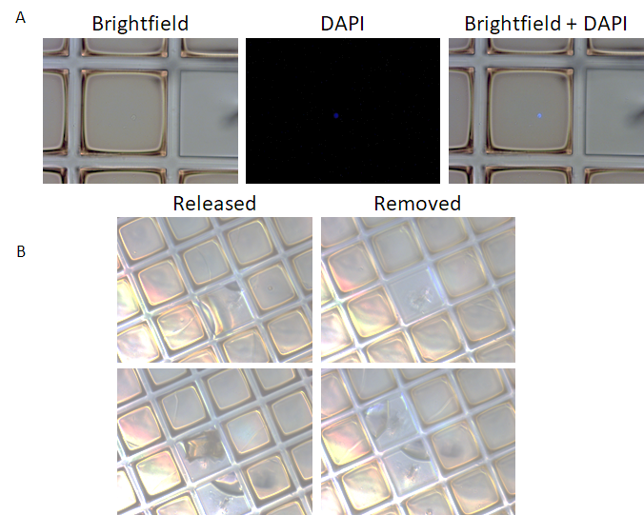
Figure 4. Manual picking of rafts containing the nuclei of interest. (A) A CellRaft with a single nucleus stained by DAPI. (C) Example of released and removed CellRafts.

- Place the magnetic wand in the tubes containing DNase-I diluted solution.
Critical note: DNAse-I solution is used to reduce cross-contamination between samples. This may require optimisation in each lab.
- Wash the wand with 70% EtOH and then with dH2O
- Capture, transfer and release the released raft to the already prepared 0.2ml tubes with the buffer needed for scWGA using the magnetic want. Then, centrifuge the tubes briefly (Figure 5)

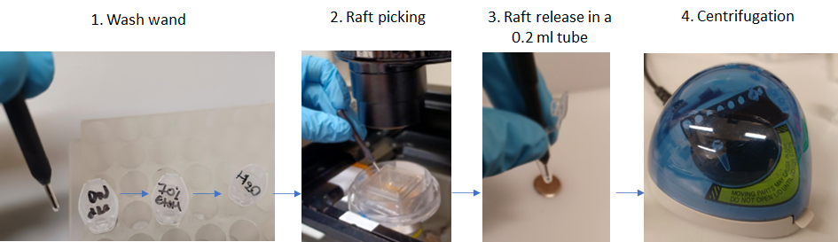
Figure 5. Wand washing, raft picking and release in 0.2 ml tubes.

- When performing CellRaft isolation, it is highly recommended to ensure the rafts are properly released at the bottom of the tube and not in the tube wall, as they would desiccate. To do so, visually inspect every tube after collection under a stereoscopic microscope; rafts will appear as small orange squares.
Critical note: As controls, use at least one of each of the following per experiment:
- Negative control 1: a tube with no raft, in which the magnetic wand has been dipped after it was dipped into the array covering fluid
- Negative control 2: a raft with no nucleus
- Positive control: 15 pg of genomic DNA
- Freeze the samples @-80ºC or proceed directly to scWGA
For scWGA we have used the following methodologies:
- PicoPlex (R300670, R300672 and R300722) according to Takara’s protocols
- dMDA with heat denaturation and Buffer Generation (Attach dMDA protocol)
- PTA (Attach PTA protocol) but for step 7: incubate for 20 min @RT

Note: So far, we have successfully used the PicoPlex method with and without nuclei immunostaining. However, we have not tested the dMDA and PTA methods in combination with nuclei staining but we have just stained the nuclei with DAPI staining.

References:
- Mullen RJ, Buck CR, Smith AM. NeuN, a neuronal specific nuclear protein in vertebrates. Development. 1992;116(1):201-211. doi:10.1242/dev.116.1.201
- Wolf HK, Buslei R, Schmidt-Kastner R, et al. NeuN: a useful neuronal marker for diagnostic histopathology. J Histochem Cytochem. 1996;44(10):1167-1171. doi:10.1177/44.10.8813082
- Cannon JR, Greenamyre JT. NeuN is not a reliable marker of dopamine neurons in rat substantia nigra. Neurosci Lett. 2009;464(1):14-17.
- Reed PJ, Wang M, Erwin JA et al (2017) Single-Cell Whole Genome Amplification and Sequencing to Study Neuronal Mosaicism and Diversity. In: Frade J., Gage F. (eds) Genomic Mosaicism in Neurons and Other Cell Types. Neuromethods, vol 131. Humana Press, New York, NY

